Class Test on ‘Three intersecting lines’ (Class 7)
Full marks: 15

Choose the correct option: 1x4=4
- In a △ ABC, ∠A=35∘ and ∠B=65∘, then the measure of ∠C is
(a) 50⁰ (b) 80⁰ (c) 30⁰ (d) 60⁰
- The hypotenuse of a right triangle is 17 cm long. If one of the remaining two sides is 8 cm in length, then the length of the other side is
(a) 15 cm (b) 12 cm (c) 13 cm (d) none of these.
- How many acute angles can a right triangle have?
(a) 1 (b) 2 (c) 3 (d) 0
- Possible side lengths for an isosceles triangle can be :
(a) 4 cm, 4 cm, 8 cm (b) 6 cm, 6 cm, 13 cm
(c) 3 cm, 3 cm, 5 cm (d) 1 cm, 1 cm, 2 cm
- CASE STUDY: 1x4=4
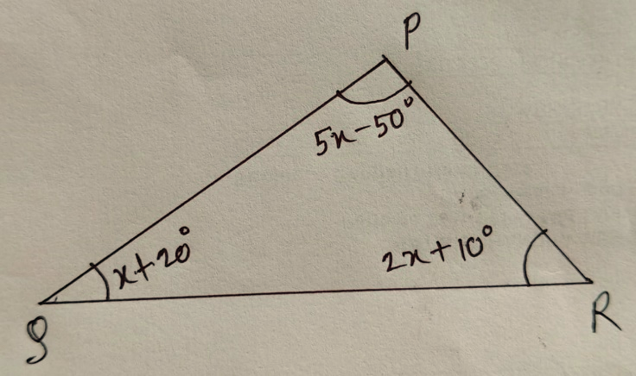
Suresh having a garden near Delhi. In the garden there are many trees and flower plants. One day due to heavy rain and storm, one of the trees is broken as shown in figure. The height of the unbroken part is 15m and the broken part of the tree has fallen at 20 m away from the base of the tree. Based on the information answer the following
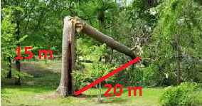

Fig. I Fig. II
I. What is the length of the broken part?
II. What is the original height of the tree?
III. Find the value of x in the given figure II.
IV. Check whether 5 cm, 8 cm, 17 cm can be the sides of a right-angled triangle.

Answer the following questions.
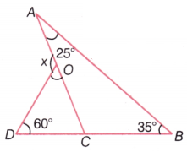
- In the given figure, find the value of x. [2]

- Each of the two equal angles of an isosceles triangle is twice of third angle. Find all the angles. [2]
- Construct triangle ABC whose $∠A={30}^{0}$, AB = 5 cm and $∠B={50}^{0}$ and also construct an altitude from A to BC. [3]

